CSA1701 – ARTIFICIAL INTELLIGENCE

NAME: M.Greeshma
REG.NO: 192524195
FACULTY: Dr. Jeena R

Program 1: Python Program to Solve 8-Puzzle Problem
Aim
To develop a Python program that solves the 8-Puzzle Problem using a search algorithm such as Breadth-First Search (BFS) to find the shortest sequence of moves from the initial state to the goal state.
Algorithm
- Represent the puzzle as a 3×3 matrix.
- Define the initial state and goal state.
- Locate the empty tile (0).
- Generate all possible moves (up, down, left, right).
- Use Breadth-First Search (BFS) to explore possible states.
- Keep track of visited states to avoid repeated exploration.
- If the goal state is reached, display the solution path.
- If all possible states are exhausted, report that no solution exists.

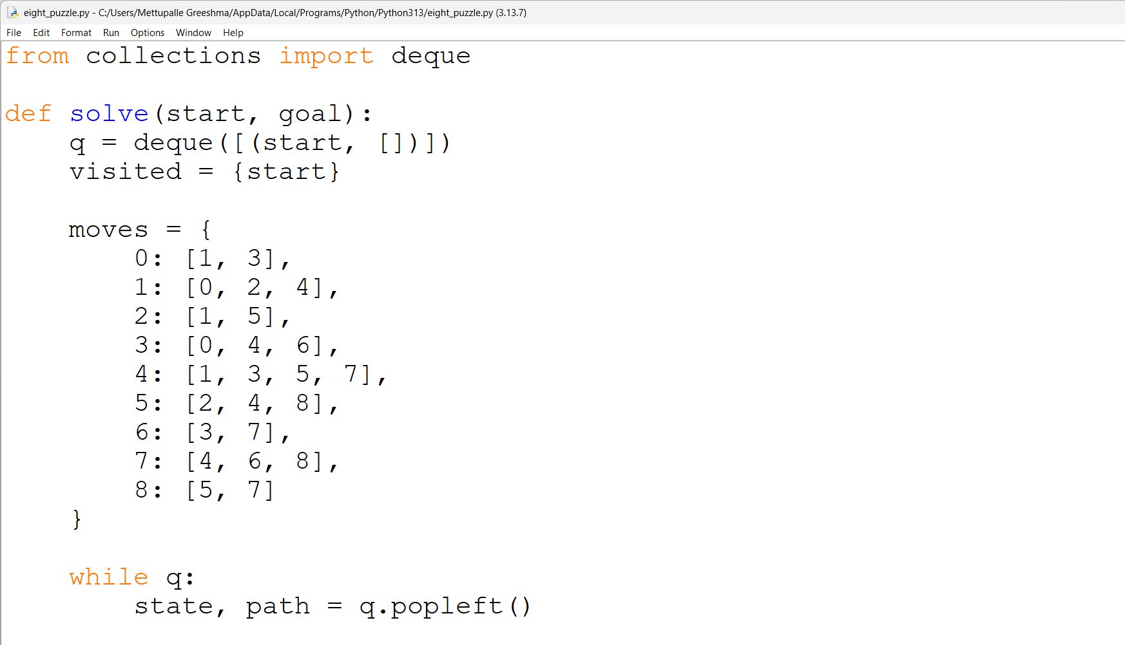
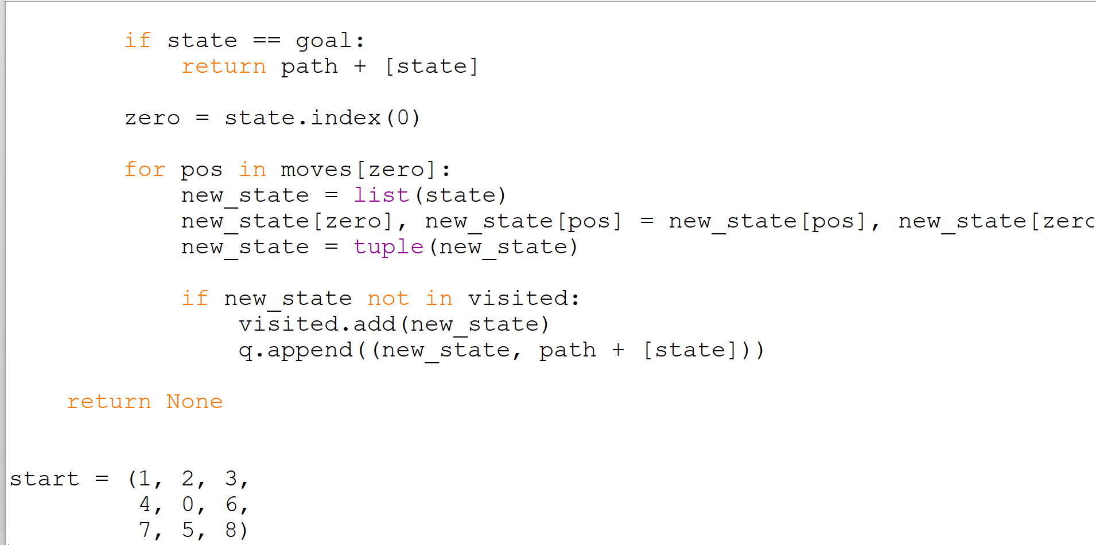
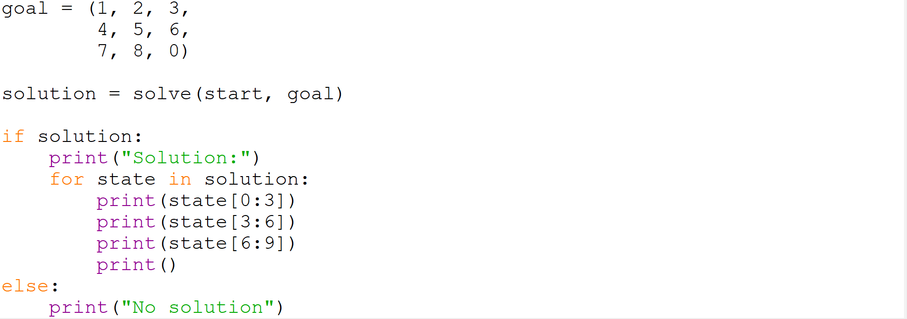
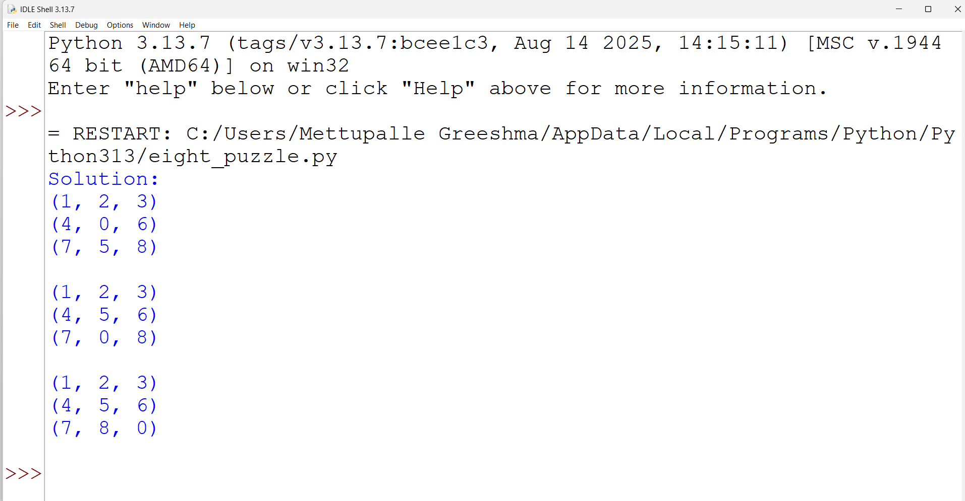

Result
Thus, the 8-Puzzle Problem was successfully solved using Python using the Breadth-First Search (BFS) algorithm.

Program 2: Python Program to Solve 8-Queens Problem
Aim
To develop a Python program to solve the 8-Queens Problem using the Backtracking algorithm by placing 8 queens on an 8×8 chessboard such that no two queens attack each other.
Algorithm
- Represent the chessboard as an 8×8 matrix.
- Start placing queens row by row.
- Check whether the current position is safe.
- A queen can be placed only if no other queen is in the same column or diagonal.
- If the position is safe, place the queen and move to the next row.
- If no safe position is available, backtrack to the previous row.
- Continue until all 8 queens are placed successfully.
- Display the solution on the chessboard.

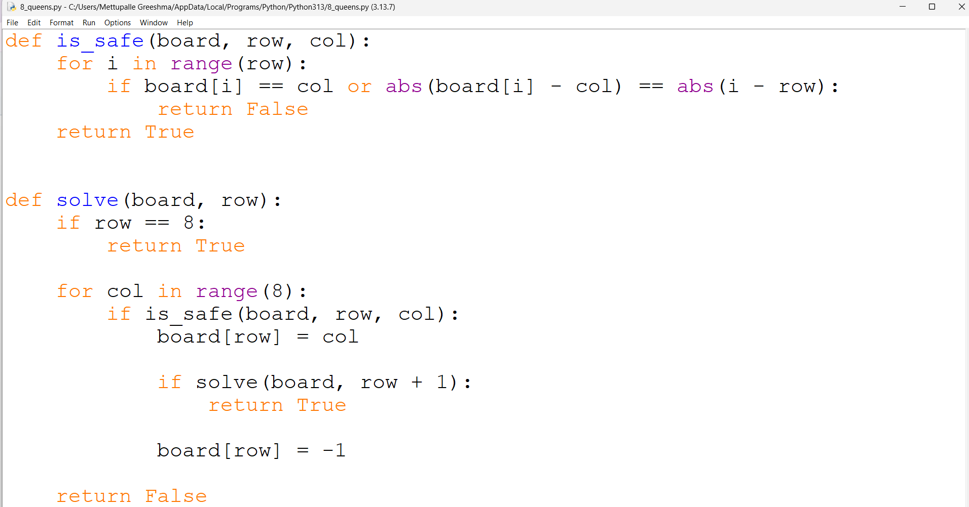
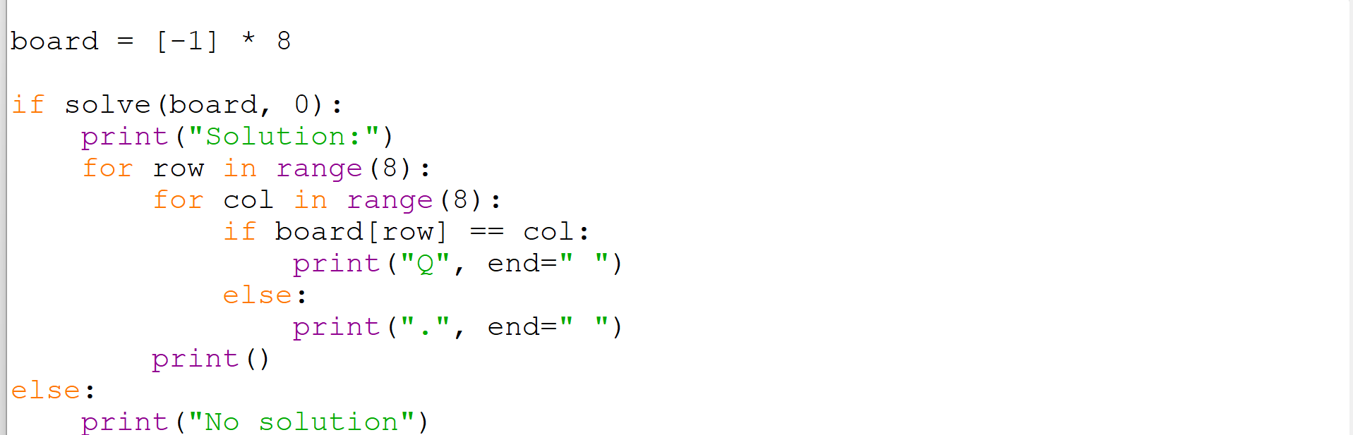
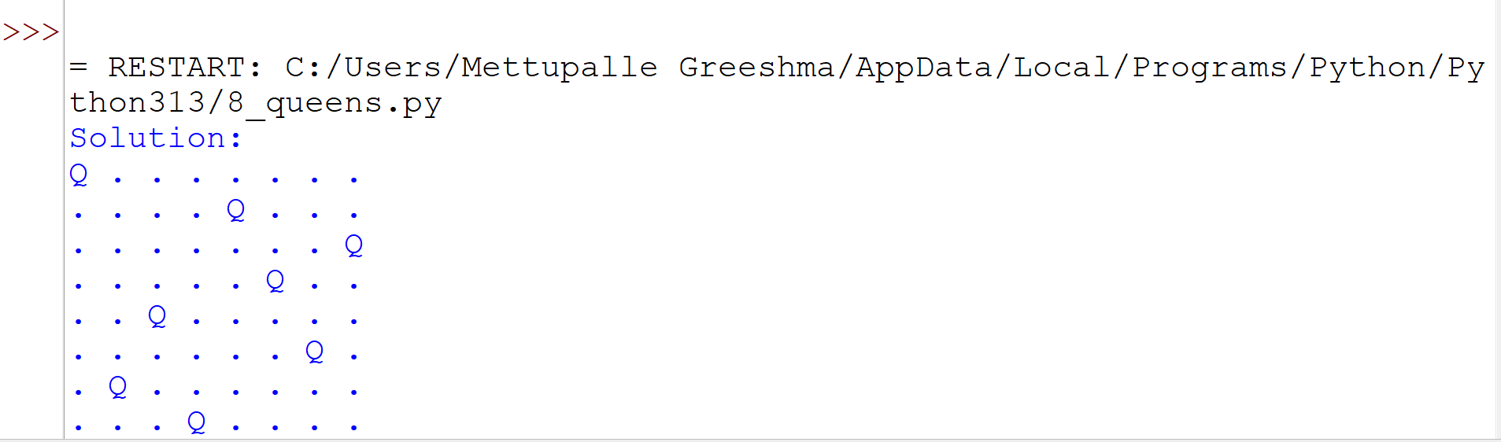

Result
Thus, the 8-Queens Problem was successfully solved using Python using the Backtracking algorithm, with 8 queens placed on the chessboard such that no two queens attack each other.
Program 3: Python Program to Solve Water Jug Problem
Aim
To develop a Python program to solve the Water Jug Problem using the Breadth-First Search (BFS) algorithm to obtain the required quantity of water.
Algorithm
- Define the capacities of the two water jugs.
- Define the target quantity of water to be measured.
- Represent each state as the amount of water present in both jugs.
- Generate all possible operations such as filling, emptying, and transferring water between the jugs.
- Use Breadth-First Search (BFS) to explore the possible states.
- Keep track of visited states to avoid repeated exploration.
- If the target quantity is reached, display the sequence of states.
- If all possible states are exhausted, report that no solution exists.

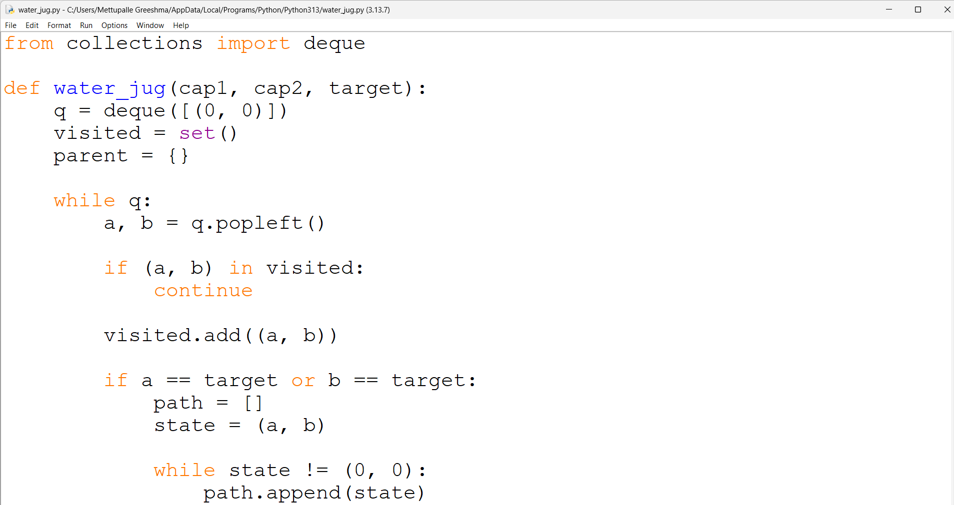
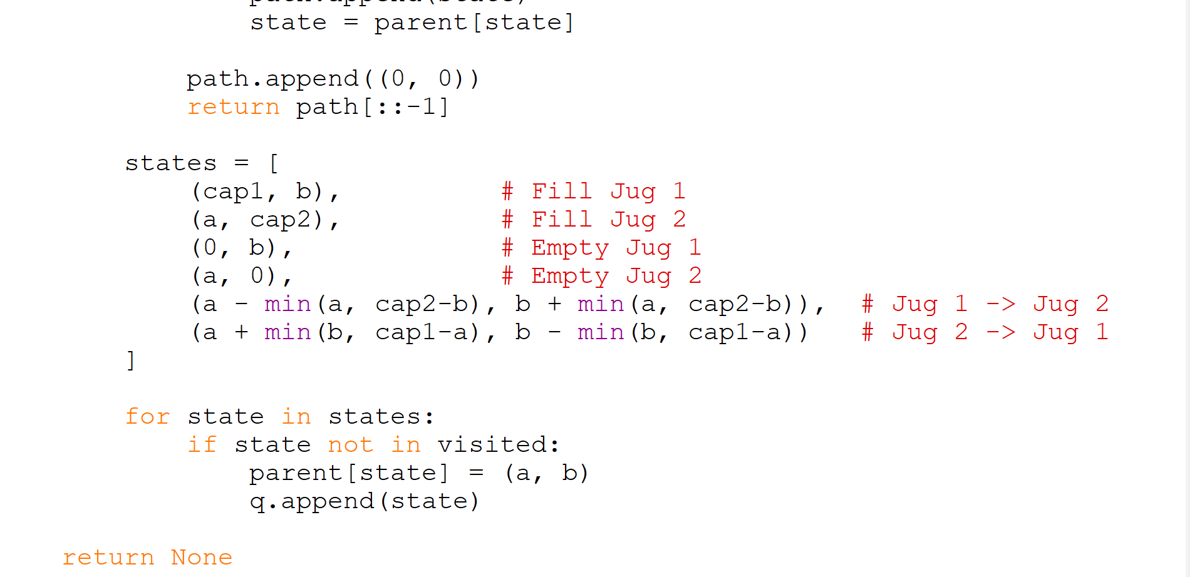
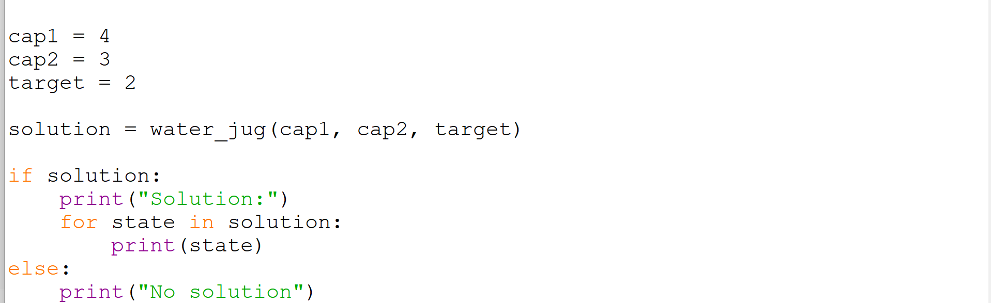
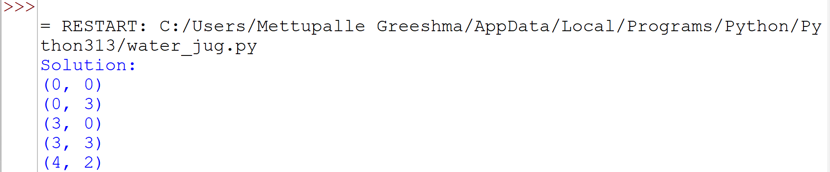

Result
Thus, the Water Jug Problem was successfully solved using Python using the Breadth-First Search (BFS) algorithm, and the required quantity of water was obtained.

Program 4: Python Program to Solve Crypt-Arithmetic Problem
Aim
To develop a Python program to solve a Crypt-Arithmetic Problem by assigning unique digits to letters such that the given arithmetic equation is satisfied.
Algorithm
- Define the words involved in the crypt-arithmetic problem.
- Identify all unique letters in the words.
- Assign different digits from 0 to 9 to each letter.
- Ensure that the first letter of each word is not assigned zero.
- Convert the letters into their corresponding numerical values.
- Check whether the arithmetic equation is satisfied.
- If a valid assignment is found, display the solution.
- If no valid assignment exists, report that no solution exists.

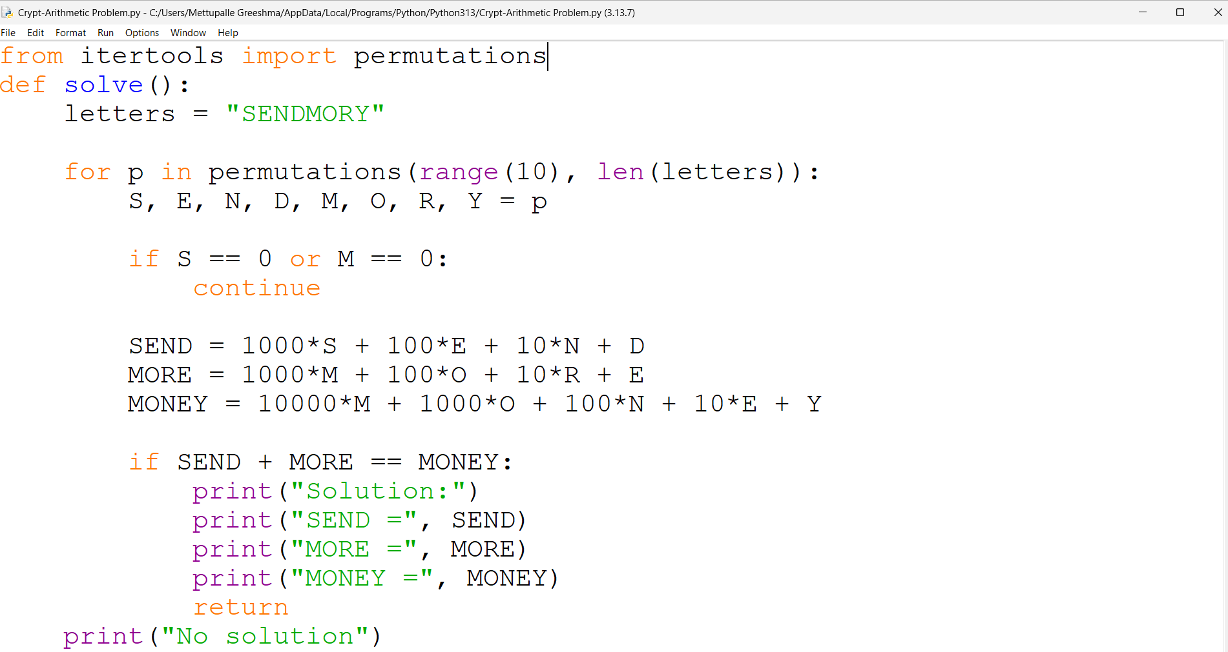
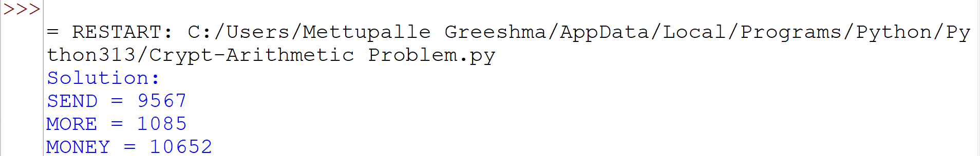

Result
Thus, the Crypt-Arithmetic Problem was successfully solved using Python, and a valid digit assignment satisfying the given arithmetic equation was obtained.

Program 5: Python Program to Solve Missionaries and Cannibals Problem
Aim
To develop a Python program to solve the Missionaries and Cannibals Problem using the Breadth-First Search (BFS) algorithm while ensuring that the missionaries are never outnumbered by the cannibals.
Algorithm
- Represent the state using the number of missionaries, cannibals, and the position of the boat.
- Define the initial state as 3 missionaries, 3 cannibals, and the boat on the starting side.
- Define the goal state as all missionaries and cannibals safely reaching the opposite side.
- Generate all possible movements of one or two people in the boat.
- Check whether each new state is safe and valid.
- Use Breadth-First Search (BFS) to explore the possible states.
- Keep track of visited states to avoid repeated exploration.
- If the goal state is reached, display the sequence of states.
- If no valid solution exists, report that no solution exists.

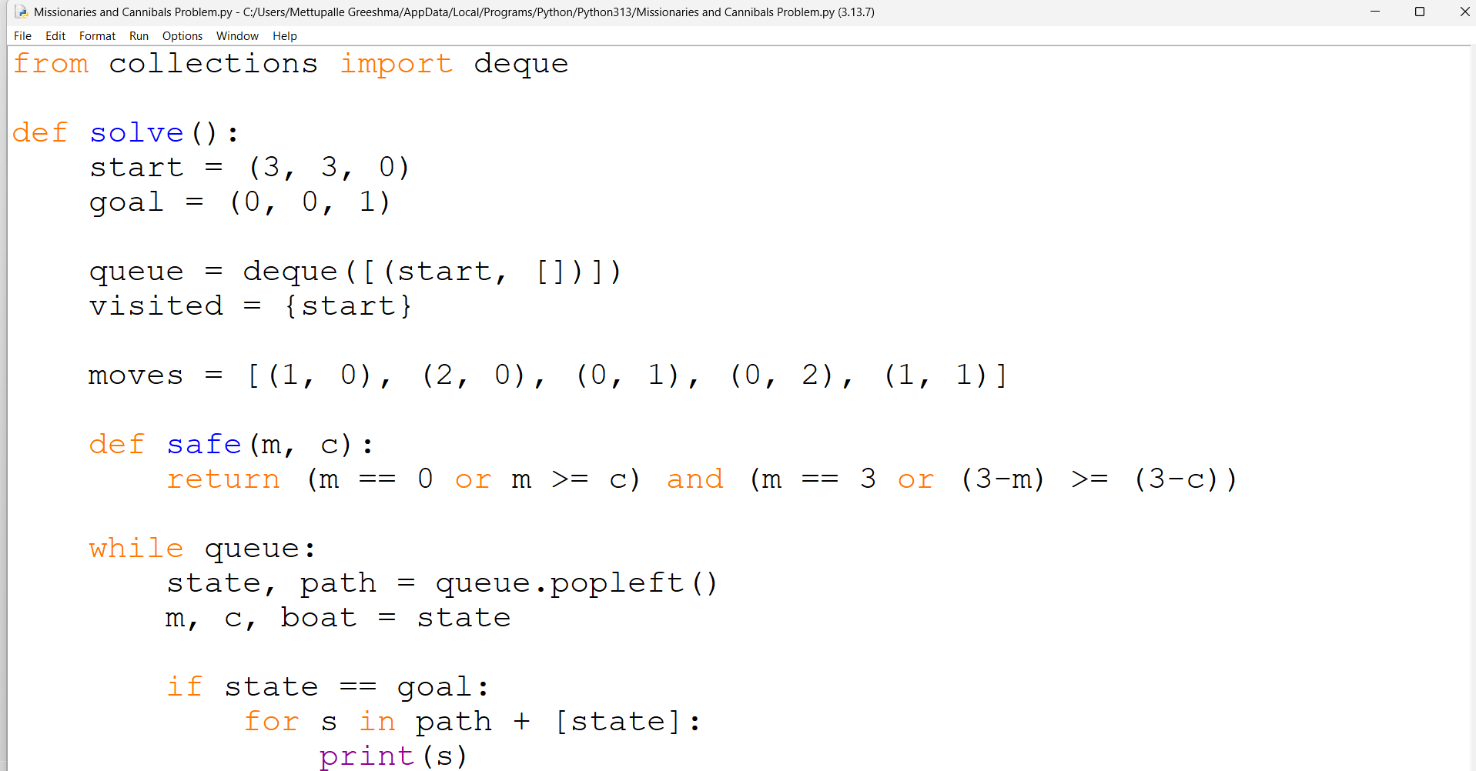
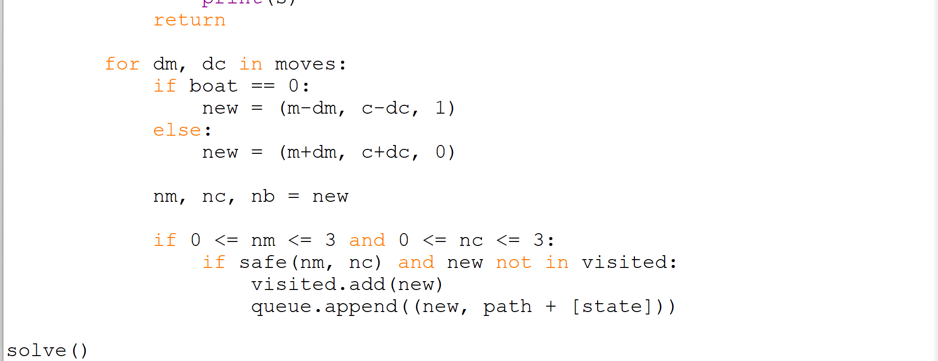
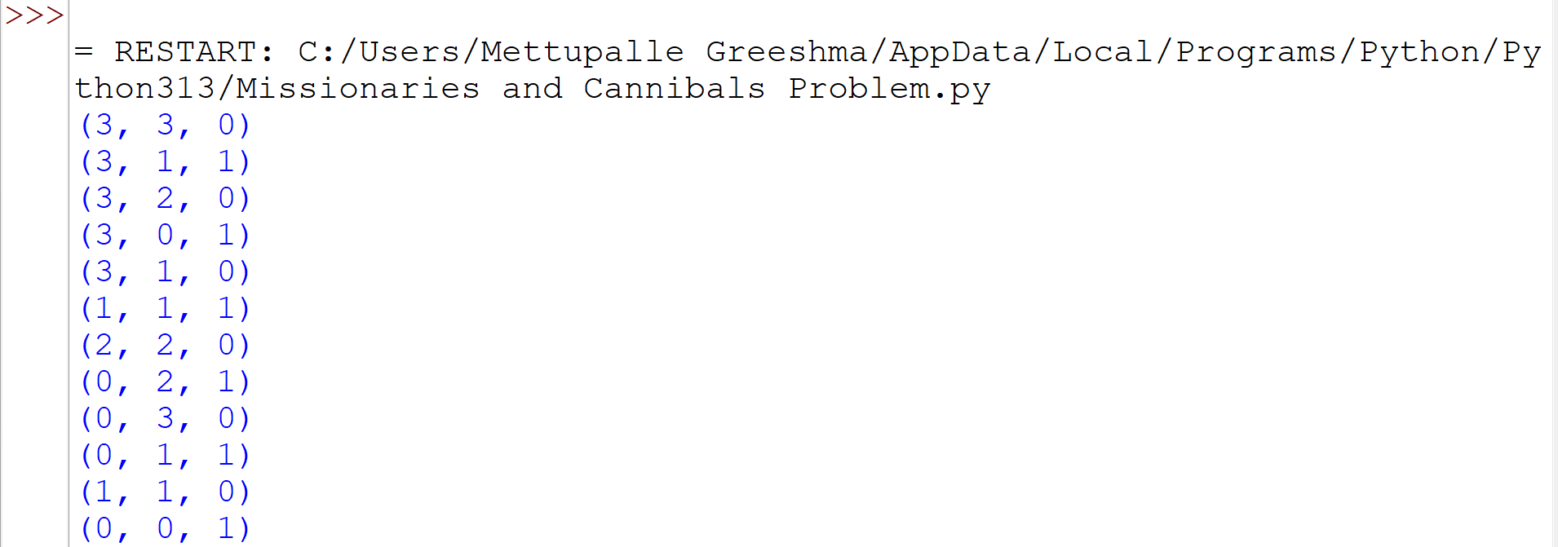

Result
Thus, the Missionaries and Cannibals Problem was successfully solved using Python using the Breadth-First Search (BFS) algorithm, and all missionaries and cannibals were safely transferred to the opposite side.

Program 6: Python Program to Solve Vacuum Cleaning Problem
Aim
To develop a Python program to solve the Vacuum Cleaning Problem in Artificial Intelligence by cleaning dirty rooms using an intelligent vacuum cleaner agent.
Algorithm
- Represent the environment using two rooms, A and B.
- Initialize both rooms as dirty.
- Set the vacuum cleaner's initial location to Room A.
- Check the status of the current room.
- If the room is dirty, clean it and update its status to clean.
- Move the vacuum cleaner from Room A to Room B.
- Repeat the cleaning process for Room B.
- Display the status of both rooms after cleaning.
- Stop the program when both rooms are clean.

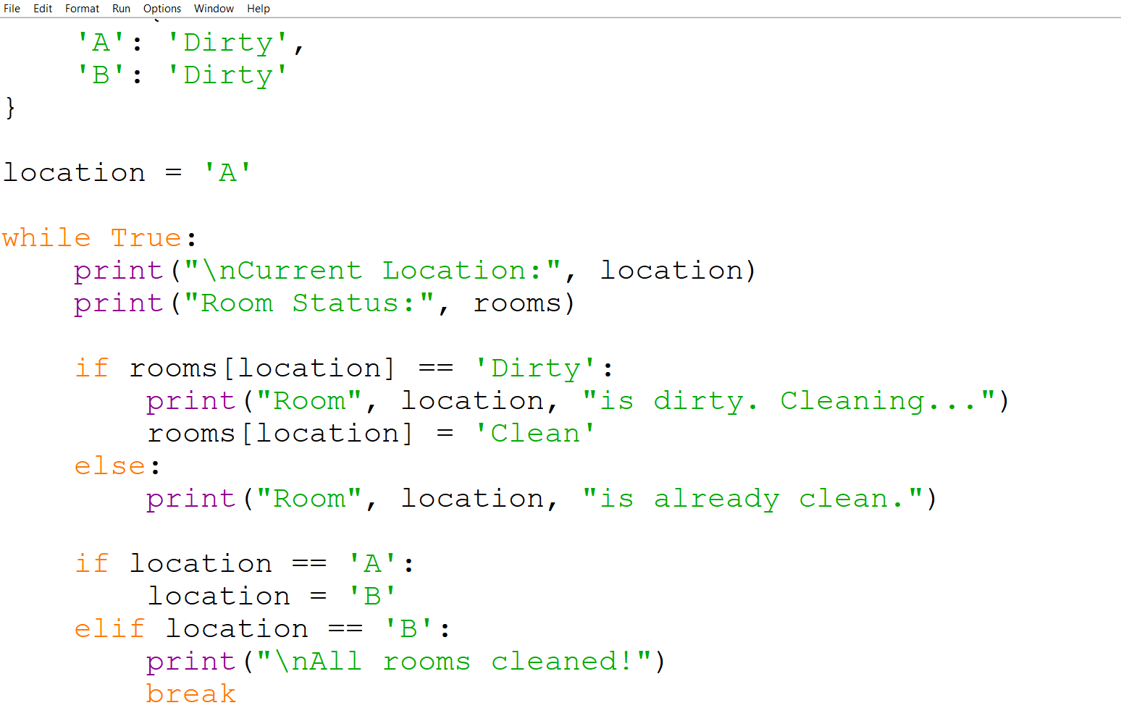
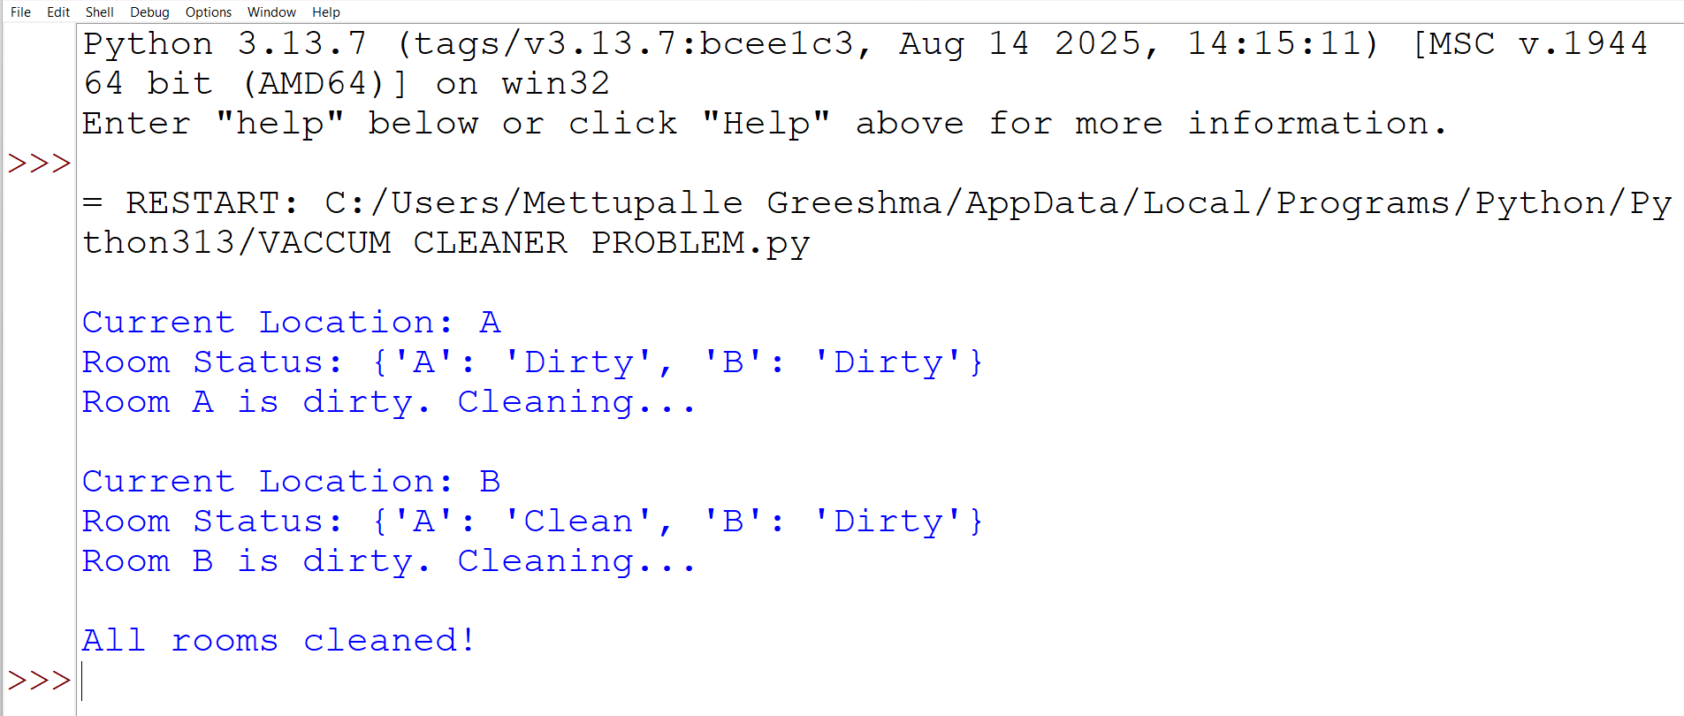

Result
Thus, the Vacuum Cleaning Problem was successfully solved using Python, and both rooms were cleaned by the vacuum cleaner agent.

